**Software Design Specification**

**for**

**Geology Application**

**Version: 1.0**

**Date created:**

**October 26th, 2021**

**Prepared by:**

**Demetrios Green**

**Ben Pink**

**Clayton Rath**

**David Vegter**

**System Dataflow Diagram**

<https://lucid.app/lucidchart/7c54c2d1-d6f5-42e9-9f74-481614c05f03/edit?viewport_loc=-128%2C-96%2C5112%2C2338%2C0_0&invitationId=inv_2167c2d2-4102-4158-ad7a-33490b91b880>

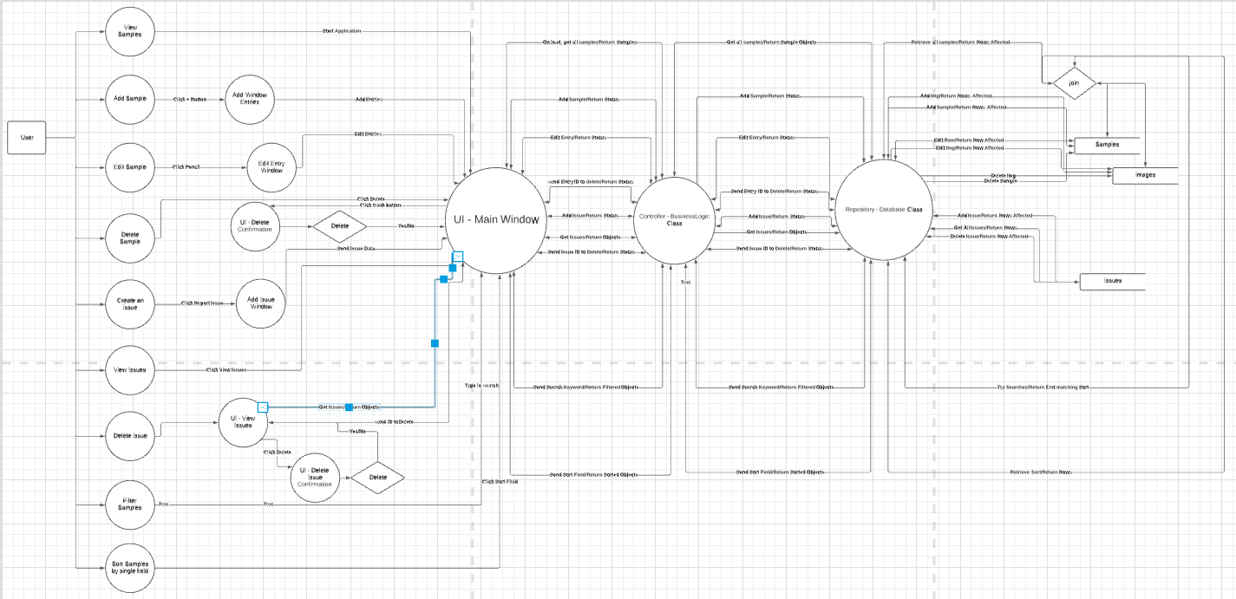

**UML Class Diagram**

**Database Schema Diagram**

